**CHAPTER III**

**METHODS AND PROCEDURES**

This chapter explains the procedures needed to be used in research. This chapter discusses the research design, respondents of the study, data gathering tools, data gathering procedures, and system development which is essential to the study. This describes the procedure that must be followed in order to create the flow of system.

**Research Design**

The researchers followed a series of steps to arrive at the main target or objective, which was done by the practical understanding of a suitable technique. This part of the study will discuss the procedures to be used by the researchers to be able to acquire the needed data and details for the study. Furthermore, the output of the research will be fully developed once fulfilled.

Quantitative and Qualitative data will be collected on the research in short, the researchers will be integrate a mixed method of data collection. The researchers will be using a descriptive type of research to gather information. Descriptive research wherein details are accurately collected without altering their background. The analysis of the population sample will help in the formation of the system.

The descriptive type of research is an appropriate choice for the topic since this investigates one or more variables. In contrast to experimental research, which the researcher does not influence or manipulate the variables, but rather observes and measures them.

**Respondents of the Study**

To gather the necessary data, the researchers will use a non-probability sampling technique. Purposive sampling is a sampling method which enables the researchers to choose their own sample from a population. This method of sampling will be used for its convenience especially during this time of pandemic. According to [48], the sampling design is based on the judgment of the researcher as to who will provide the best information to succeed for the objectives of the study. By using the strategy, the process has the advantage of being time-saving and effective with the study.

Consequently, the researchers want to access a particular group of people that will be needed with the researchers’ study.

**Table 1. Respondents of the Study**

|  |  |
| --- | --- |
| **Respondent Category** | **No. of Respondents** |
| Users | 15 |
| Web Development expert | 10 |
| Total | 25 |

Table 1 shows the total number of the population of the given respondents needed for the study. It has three categories which are preschool teachers from Cabuyao City, parents or guardian of the student, and web development experts.

The respondents of the study are comprised of fifteen (15) users and ten (10) web-development experts totaling into twenty-five (25) overall respondents. The users are composed of preschool teachers and parents and the chosen experts must have atleast five years of work experience as a software or web developer, exhibits prowess in programming and web design, and adept in the fields of software and web development.

**Data Gathering Tools**

The researchers will utilize multiple tools to gather important data which will help in the process of creating both the research and the system itself. Such data gathering tools shall be used to gather relevant information thus, aiding the researcher’s progress.

An interview is the activity between an interviewer and interviewee wherein an interactive conversational exchange between both participants in which the interviewer’s questions intended to gather information are answered by the interviewee. The interview will be used to garner relevant information in relation to the proposed system to be developed.

The internet contains a plethora of information about almost anything including many scholarly works. An internet research is to be conducted by the researchers in order to collect data from related studies posted on the internet. The information that will be gathered from the online based resources will be beneficial during the research.

A library research makes use of the articles, researches, and journals that are shelved and can be easily accessed in a library. Conducting a library research will also be useful to the researchers as they can browse for studies about computer-assisted instruction and education-based systems and other informative resources. Finding similar studies to the current research will be used as references to further improve on both the research and the system.

A survey is a set of questions with a choice of answers targeted at a specific population used to gather information from the respondents. The survey will be utilized to gather feedback from using the finished system.

**Data Gathering Procedures**

The researchers reached out to the client and contacted them through a social media platform. This was done to look for possible suggestions and recommendations with regards to the system to be developed.

The researchers then began to look for journals and related studies online with the use of their personal computers at home. Browsing the internet is used to collect reliable information helped in correlating supporting data for the research.

Even after the extensive search of related information on the internet, the researchers proceeded to go to the school library in Pamantasan ng Cabuyao. The purpose was to look for more reliable resources like previous studies and researches which prove to be more credible than other online references.

The researchers will then gather data from the respondents via a survey. The survey will utilize the Likert scale as its survey scale which is comprised of five possible responses on each survey item depending on the type of questions the researchers will impose on their respondents.

**Data Analysis Plan**

The data that will be collected from the survey shall be presented in a tabular format. The scale to be used for the survey is the Likert scale. The Likert scale assumes that the intensity of an attitude is linear and uses five to seven linear responses to assume the measure of an attitude. The survey will have five (5) options to choose from each with its corresponding numeric code as shown below.

|  |  |
| --- | --- |
| Option | Code |
| Strongly Agree (SA) | 5 |
| Agree (A) | 4 |
| Undecided (U) | 3 |
| Disagree (D) | 2 |
| Strongly Disagree (SD) | 1 |

In determining the average responses across the respondents, the median will be used to evaluate the average scores. The median and percentage will be used as the main statistical tools for tallying the responses from the survey.

**System Development**

The methodology to be used in developing the proposed system is the Scrum agile methodology. The Scrum agile methodology is a widely used framework in the development of system software that is both lightweight and easy to understand. It is composed of several phases which are Initiate, Plan and Estimate, Implement, Review and Retrospect, and Release.

During the Initiate phase, the researchers will have to create a summary of all the requirements and features that will be implemented to the proposed system. The overall design of the proposed system will be formulated by the researchers.

A class diagram is a type of diagram which is part of a unified modeling language (UML) that defines and gives the overview and structure of the system in terms of classes, methods, attributes, and the relationship amongst the different classes.

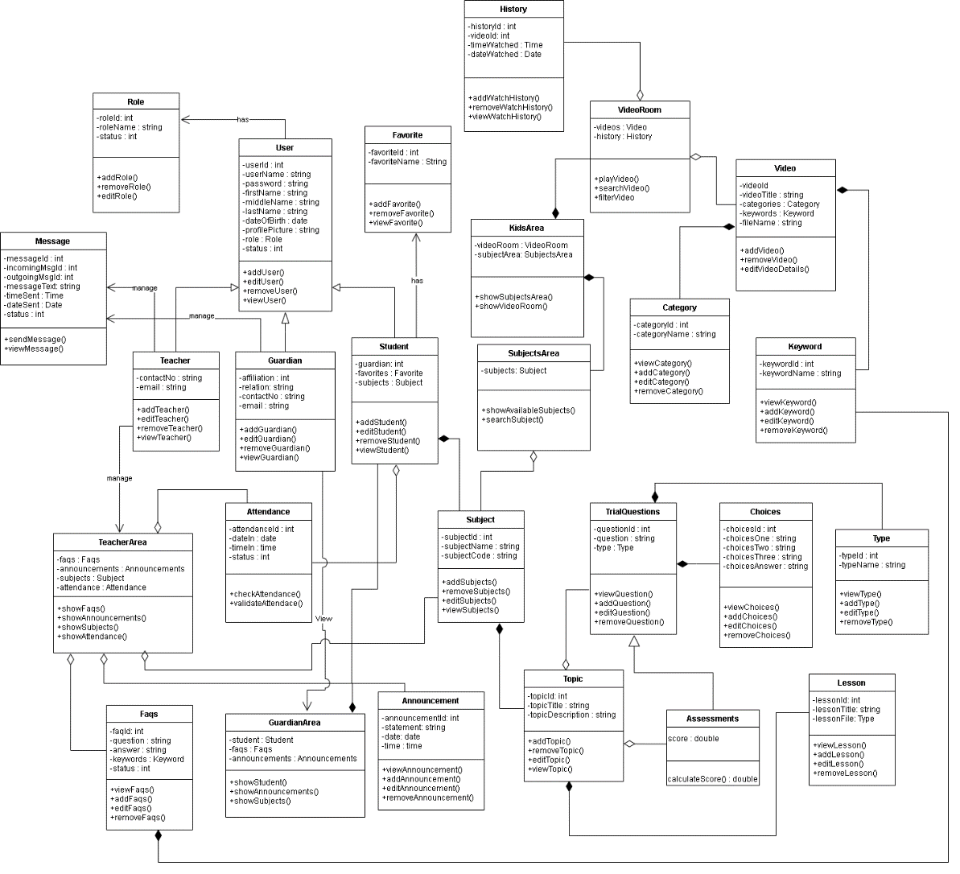

**Figure 2. Class Diagram**

Figure 1 shows all the classes that will be used on the Web-based Computer-Aided Instruction for Nursery Students and their corresponding methods and the relationships and the attributes of each class in the diagram. The diagram consists of class for Role, User, Teacher, FAQs, Attendance, Parent, Student, GuardianArea, TeachersArea, Announcement, Subject, Subjects Area, Subject Grade, KidsArea, Video, VideoRoom, Category, Keywords, TrialQuestion, Topic, Assessments, and Choices.

The parents, student, and teacher inherit the User table’s instances or properties which provide the needs for users, such as username, password, first name, middle name, last name, sex, date of birth, profile, picture, role, and status of an account. The parent has property affiliation, email, and contact number. The teacher has properties of email and contact number. While the student contains the section and their parent.

The kid’s area class has a video room and subject area. The video room class has videos and a history class. The subject area class has subjects. The video class contains a property video title, category, keywords, and file name. The history class contains a property of video, time watched and date watched. The subject class is composed of topics and has a property of subject name and subject code. While the topic class contains a topic title and topic description. The assessment class has score property and inherits all properties of the trial question class that are composed of choices and has a property of question.

The teacher manages the teacher’s area class which contains subjects, announcements, FAQs, and attendance of the student. The parent has an access to view the parent’s area class that contains the student information, faqs, announcements. They both manage the message class to contact each other if they have questions. It depicts the system's overall presentation, as well as the various objects included in the proposed system, as well as their relationships and how objects interact with one another.

In the Plan and Estimate phase, the researchers will start to layout the activities for the proposed system. The researchers will establish the design for every activity to be accomplished.

Use case diagrams are a visual representation of a system's requirements, including internal and external factors. The roles of the actors are portrayed across these diagrams. The purpose of this diagram is to provide an overview of the actors and their roles, functionalities, as well as dependencies presented in the diagram.

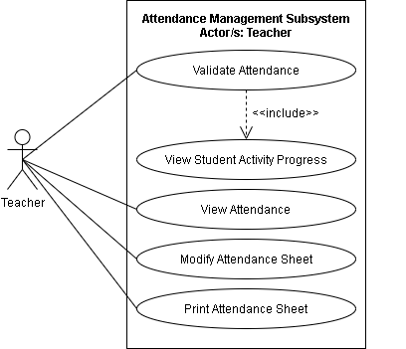

**Figure 2. Use Case Diagram for Attendance Management Subsystem**

Figure 2 shows the Use case diagram for the Attendance Management Subsystem. The illustration shows the capabilities of the teacher. The teacher can validate attendance which includes the view student’s activity progress, student’s attendance, modify attendance sheet, and print attendance sheet.

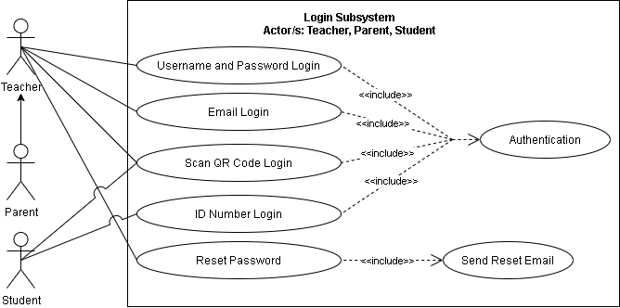

**Figure 3. A Use Case Diagram for Login Subsystem**

Figure 3 shows the Use case diagram for the Login Subsystem. The illustration shows the capabilities of teachers, parents, and students. The teacher and parents have access to username, password, e-mail, QR code, and reset password which is the primary authentication of the system. Otherwise, the student can only access the system by scanning the QR code and by its unique ID number.

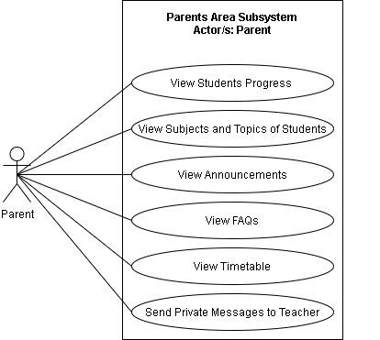

**Figure 4. Use Case Diagram for Parents Area Subsystem**

Figure 4 shows the Use case diagram for the Parents Area Subsystem. The illustration shows the capabilities of parents. The parents have access to view student’s progress, view student’s subjects and topics, view announcements, view FAQs, view Timetable, and send private message to teacher.

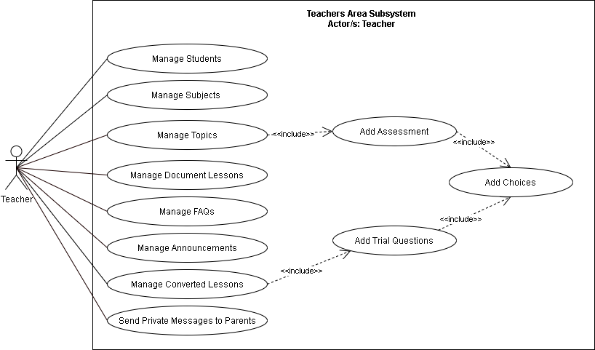

**Figure 5. Use Case Diagram for Teachers Area Subsystem**

Figure 5 shows the Use case diagram for the Teachers Area Subsystem. The illustration shows the capabilities of teachers. The teachers have access to Manage of Subjects, Manage topics which include adding of assessment and adding of choices, Manage Document Lesson, Teachers can also manage FAQs, manage announcements, and manage student cards.

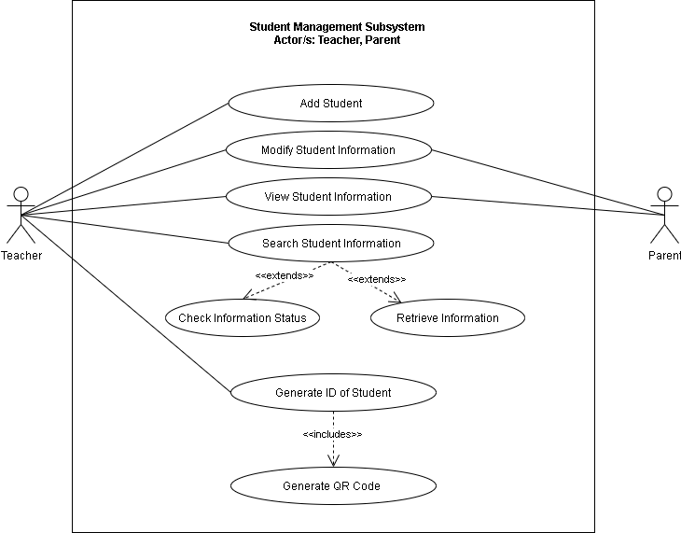

**Figure 6. Use Case Diagram for Student Management Subsystem**

Figure 6 shows the Use case diagram for the Student Management Subsystem. The illustration shows the capabilities of teachers and parents. The teachers have access to Log in which includes authentication, student registration, modify student information, view student information, search student information, manage student cards, and view student card. Otherwise, the parent has access to Log in which includes authentication, modify student information, view student information, and view student card.

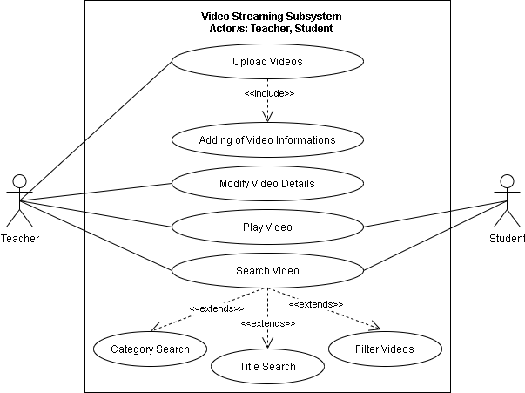

**Figure 7. Use Case Diagram for Video Streaming Subsystem**

Figure 7 shows the Use case diagram for the Video Streaming Subsystem. The illustration shows the capabilities of teacher and student. The teachers can upload videos that include its information, modify video details, search video and play video. Otherwise, the student can only search for video and play videos.

**Table 2. Use Case Analysis for Attendance Management Subsystem**

|  |  |  |  |
| --- | --- | --- | --- |
| **Actor/s** | **Event** | **Trigger** | **System Response** |
| **Teacher** | Validate Attendance | Teacher logs in | Display log-in form |
| **Teacher** | View Student Activity Progress | Teacher views the student activity progress | Display the student activity progress |
| **Teacher** | View Attendance | Teacher views the attendance | Display the attendance |
| **Teacher** | Modify Attendance Sheet | Teacher modifies the attendance sheet | Update the attendance sheet |
| **Teacher** | Print Attendance Sheet | Teacher prints attendance sheet | Print the attendance sheet |

**Table 3. Use Case Analysis for Login Subsystem**

|  |  |  |  |
| --- | --- | --- | --- |
| **Actor/s** | **Event** | **Trigger** | **System Response** |
| **Teacher, Parent** | Username and Password Login | Teacher or Parent enters username and password login | Display username and password form |
| **Teacher, Parent** | E-mail Login | Teacher or Parent enters e-mail login | Display e-mail form |
| **Teacher, Parent, Student** | Scan QR Code Login | Teacher, Parent or Student scans QR code to login | Display the QR code form |
| **Student** | ID Number Login | Student enters ID number to login | Display the ID number form |
| **Teacher, Parent** | Reset Password | Teacher or Parent resets the password of the student | Shows a reset password field |

**Table 4. Use Case Analysis for Parent Subsystem**

|  |  |  |  |
| --- | --- | --- | --- |
| **Actor/s** | **Event** | **Trigger** | **System Response** |
| **Parents** | View Students Progress | Parent views students progress | Display students progress |
| **Parents** | View Subjects and Topic of Students | Parent views the subjects and topic of student | Display subject and topic of student |
| **Parents** | View Announcements | Parent views announcements | Display announcement |
| **Parents** | View FAQs | Parent views FAQs | Displays the FAQS |
| **Parents** | View Timetable | Parent views timetable | Display the timetable |
| **Parents** | Send Private Messages to Teacher | Parent sends messages to teacher | Display message box |

**Table 5. Use Case Analysis for Teachers Area Subsystem**

|  |  |  |  |
| --- | --- | --- | --- |
| **Actor/s** | **Event** | **Trigger** | **System Response** |
| **Teacher** | Manage Students | Teacher manages student | Update the students list |
| **Teacher** | Manage Subjects | Teacher manages subjects | Updates students subject |
| **Teacher** | Manage Topics | Teacher manages topic | Updates the topic |
| **Teacher** | Manage Document Lessons | Teacher manages document lessons | Updates document lesson |
| **Teacher** | Manage FAQs | Teacher manages FAQ’s | Update the FAQs |
| **Teacher** | Manage Announcement | Teacher manages announcement | Update the announcement |
| **Teacher** | Manage Converted Lessons | Teacher converts the lesson | Converts the lesson from the teacher |
| **Teacher** | Send Private Messages to Parents | Teacher sends messages to teacher | Display message box |

**Table 6. Use Case Analysis for Student Management Subsystem**

|  |  |  |  |
| --- | --- | --- | --- |
| **Actor/s** | **Event** | **Trigger** | **System Response** |
| **Teacher** | Add Student | Teacher adds student | Updates the database of student |
| **Teacher, Parents** | Modify Student Information | Teacher or Parent modifies student’s information | Update the student information |
| **Teacher, Parents** | View Student Information | Teacher or Parent views the student’s information | Display the student information |
| **Teacher** | Search Student Information | Teacher searches student’s information | Display Check Information Status and Retrieve Information |
| **Teacher** | Generate ID of student | Teacher generates ID of student | Generate printable student ID |

**Table 7. Use Case Analysis for Video Streaming Subsystem**

|  |  |  |  |
| --- | --- | --- | --- |
| **Actor/s** | **Event** | **Trigger** | **System Response** |
| **Teacher** | Upload Videos | Teacher uploads video | Uploads video to the system |
| **Teacher** | Modify Video Details | Teacher modifies video details | Updates video details |
| **Teacher, Student** | Play Video | Teacher or Student plays video | Runs the video |
| **Teacher, Student** | Search Video | Teacher or Student searches video | Displays Category Search, Title Search and Filter Videos |

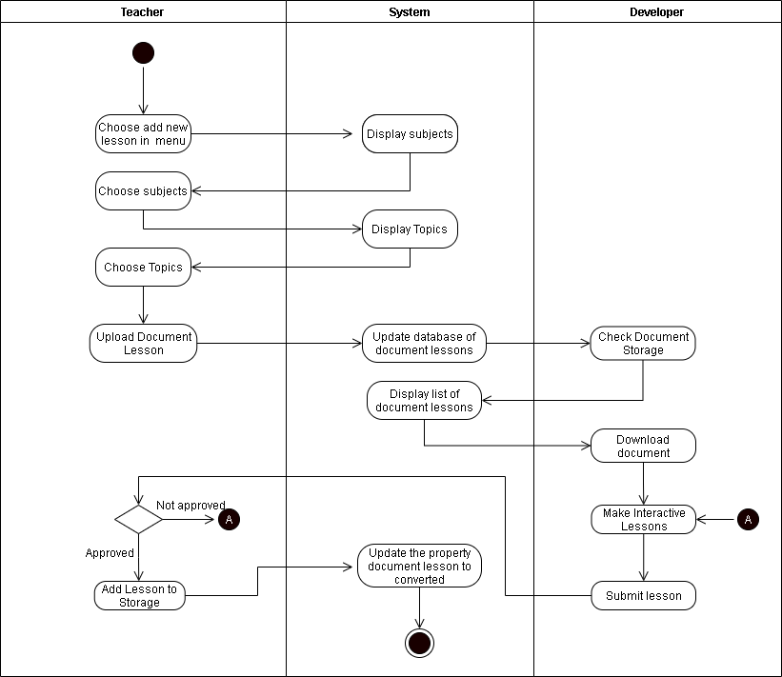The activity diagram presents the overall workflow of the activities included in the system in a graphical format. This gives a visual representation of the step by step process of activities including iterations and/or concurrent operations within the workflow.

**Figure 8. Activity Diagram for Add Interactive Lessons**

Figure 8 shows the Add Interactive Lessons. The teacher will choose to add new lesson in menu, the system will display the subjects. The teacher proceeds in choosing subject then the system will display the topics. After proceeding in choosing topics, the teacher may now upload the document lessons then the system will update the database of document lessons. Check Document Storage will be evaluated by the developers and the system will display the list of document lessons. The developer will download the list of document lessons and will proceed to the creation of interactive lesson. If the interactive lesson is approved, the system will update the documents that the teacher uploads, otherwise if the teacher does not approve the interactive lessons created by the developer, the developer will recreate the lessons.

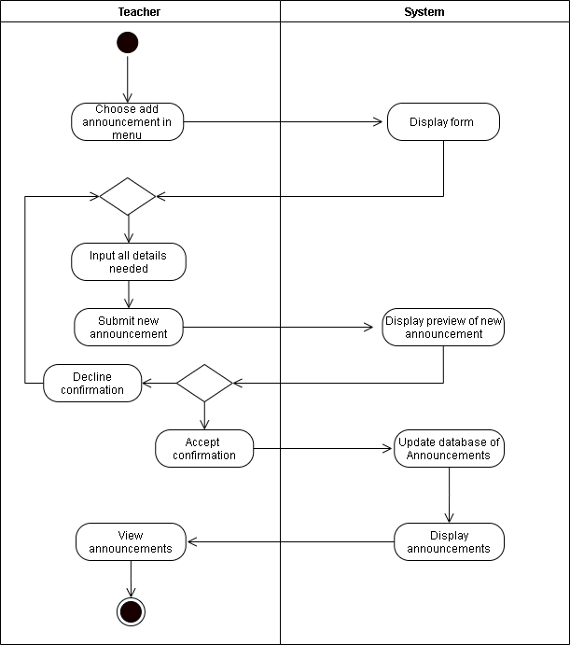

**Figure 9. Activity Diagram for Adding Announcement**

Figure 9 shows the Adding Announcement. The teacher will choose to add announcement then the system will show a display form. After completing he details needed in the announcement, the system will now display the preview of announcement. If the teacher is satisfied with the preview, the announcement can now be added to the the database. Otherwise, the teacher can repeat the process of the announcement.

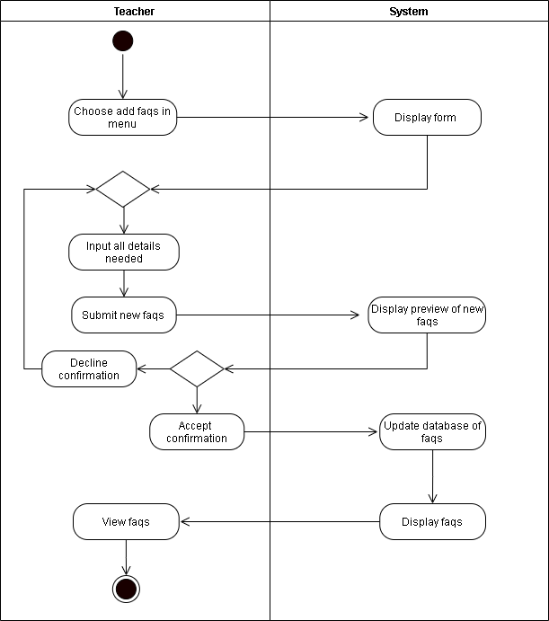

**Figure 10. Activity Diagram for Adding FAQs**

Figure 10 shows the Adding FAQs. The teacher will choose to add FAQs then the system will show a display form. After completing he details needed in the FAQs, the system will now display the preview of FAQs. If the teacher is satisfied with the preview, the FAQs can now be added to the the database. Otherwise, the teacher can repeat the process of the FAQs.

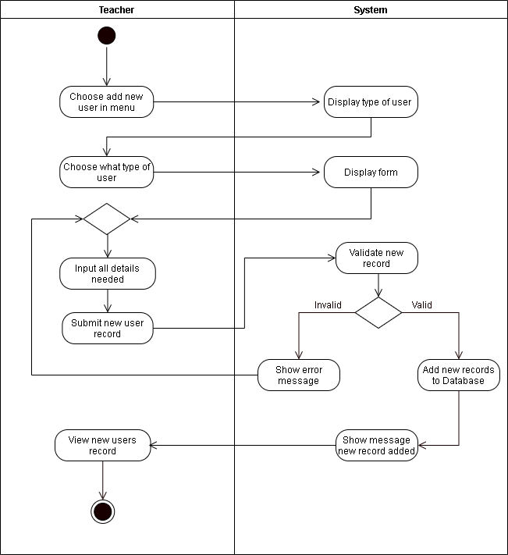

**Figure 11. Activity Diagram for Adding of Users**

Figure 11 shows the diagram for Adding of Users. The teacher will choose to add new user in menu, the system will display the type of user. After completing the details, the system will validate if there is a new record. If the system accepts a unique record, it will now proceed on the adding of user records. Otherwise, the system will show an error message and will need to recreate the process of adding users.

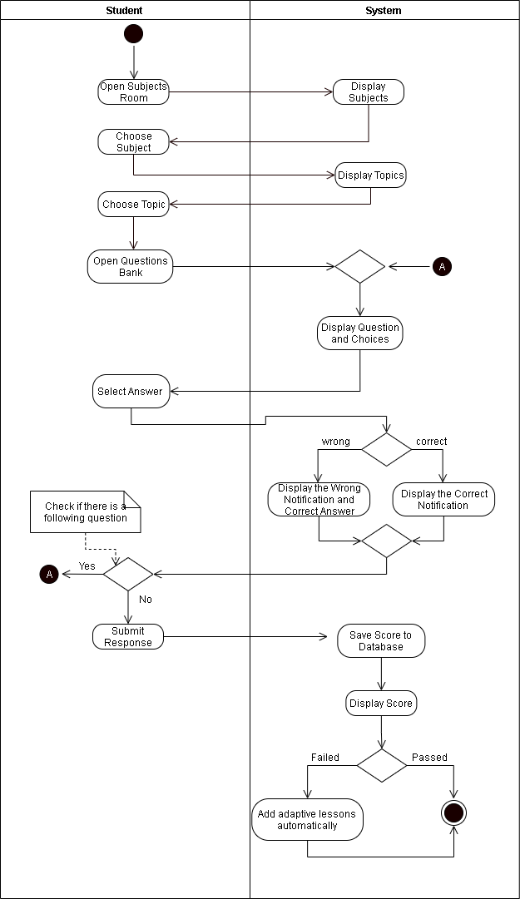

**Figure 12. Activity Diagram for Assessment Questions**

Figure 12 shows the diagram for Assessment Questions. The student will choose to open the subject room,after that the system will display the subjects. The student can choose the different topics that is being displayed by the system. Aftter choosing the right topic, the student will now proceed to in answering questions. If the student choose the right answer, the system will show display a correct notification, otherwise it will show a wrong notification and its correct answer. After answering the questions, the student may now by save. The students record will be stored in the database, and will show by the system if it is pass the system will terminate. Otherwise, adaptive lessons will automatically add.

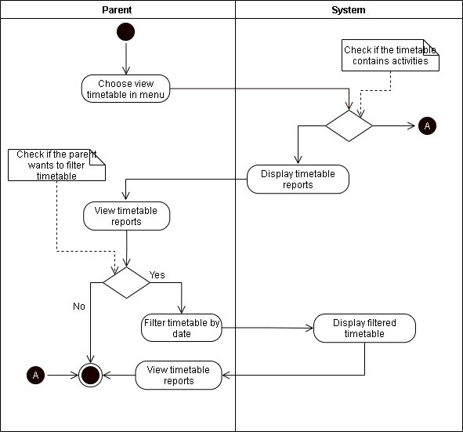

**Figure 13. Activity Diagram for Parent’s Viewing Timetable**

Figure 13 shows the diagram for Parent’s Viewing Timetable. The parent will choose view timetable in the menu and the system will display the timetable reports. The parent can filter the timetable by date and the system will display the filtered timetable.

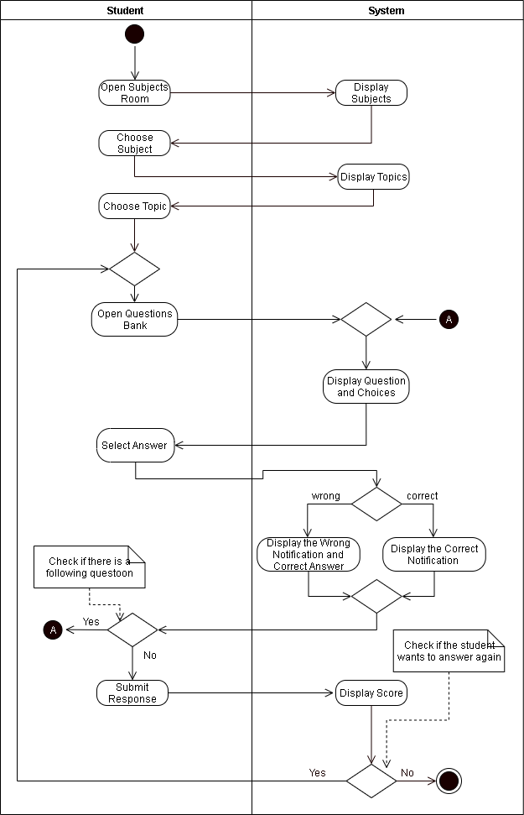

**Figure 14. Activity Diagram for Trial Question**

Figure 14 shows the diagram for Trial Questions. The student will choose to open the subject room,after that the system will display the subjects. The student can choose the different topics that is being displayed by the system. Aftter choosing the right topic, the student will now proceed to in answering questions. If the student choose the right answer, the system will show display a correct notification, otherwise it will show a wrong notification and its correct answer. After answering the questions, the student may proceed by choosing to submit the answer or to continue answering questions. The students record will be stored in the database, and will be showed by the system.

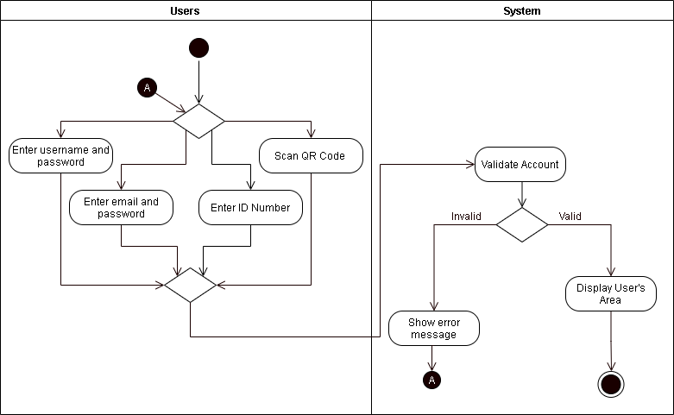

**Figure 15. Activity Diagram for Users Login**

Figure 15 shows the diagram for Users Login. The users can login by the use of username, email and password. The users can also scan QR code or ID number. The system validates if the authentication from the user is correct.

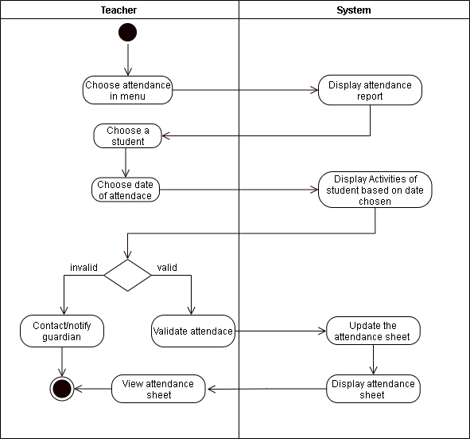

**Figure 16. Activity Diagram for Validating of Attendance**

Figure 16 shows the diagram for Validating of Attendance. The teacher will choose attendance in the menu, after that the system will display the attendance report. The teacher will choose a student to assign an attendance, after that the system will display the activities of the student based on the date. If the activities are valid, the system will update the attendance sheet. Otherwise, the teacher will contact the student’s parent or guardian for the notification of attendance.

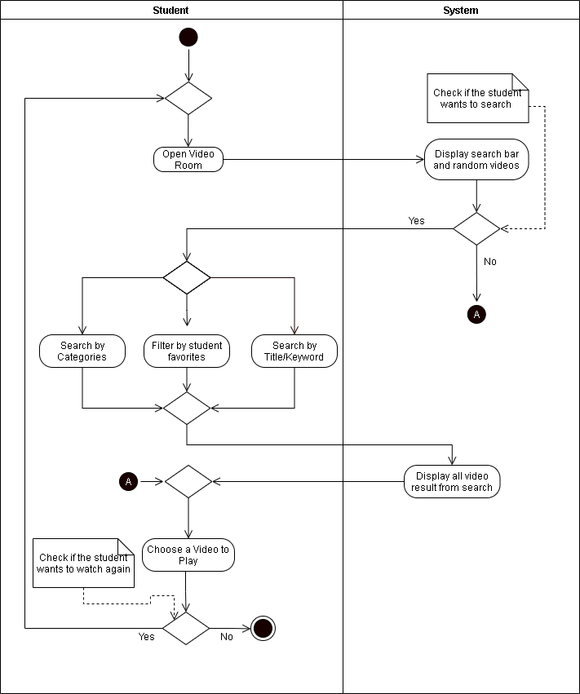

**Figure 17. Activity Diagram for Student Playing Videos**

Figure 17 shows the diagram for Student Playing Videos. The student will open the video room and the system will display a search bar and random videos. If the student want to search for a specific video, the parent’s or guardian can help them accessing the categories, filter and keywords. After that, the system will display the video specifically. The student can choose whether to play the video or pause. After the video ends, the system will check if the student wants to watch again or if not the system ends.

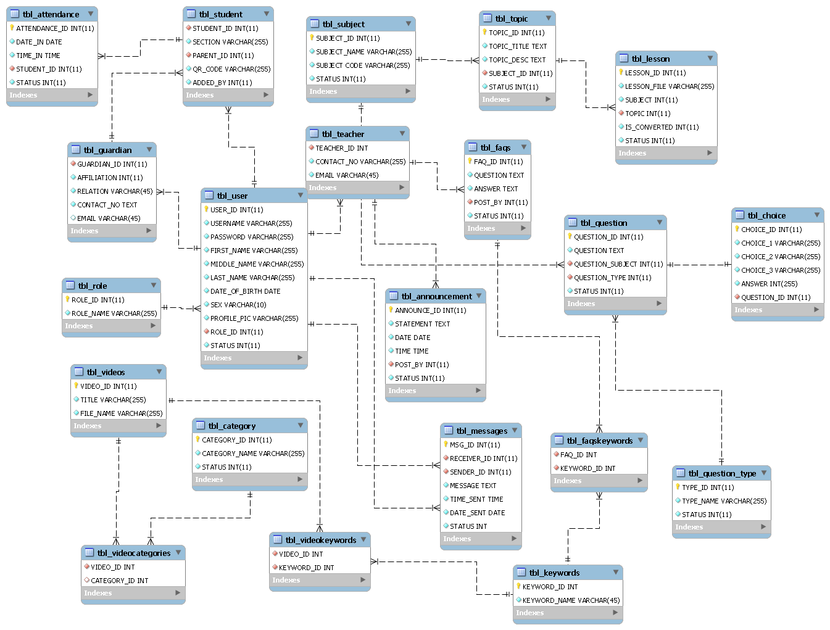An entity relationship Diagram (ERD) shows the logical structure of databases by displaying the relationships between entity sets maintained in a database. The entity-relationship diagram shows the entities and their relationships on a given database. The purpose of this diagram is to ensure a good database design.

**Figure 18. Entity Relationship Diagram**

In the Implement phase, the researchers will begin to fulfill the activities planned in the previous phase. The researchers will have a time alotted for finishing each activity.

In the Review and Retrospect phase, the finished features from doing an activity will be will be reviewed and if there are tasks not finished in time from that activity, it will be included in the next activity. The researchers will also reflect upon the challenges from the previous activities and improve on the future activities to be done.

The Release phase is when the system is completely done and the researchers are ready to send it over to the client. The researchers will also reflect upon the challenges in the whole development process that can be improved on the future projects.

**References**

[1] D. N. Arnold, “Computer-Aided Instruction” *Microsoft Encarta Online Encyclopedia*, 2000. [Online]. Available: <http://www-users.math.umn.edu/~arnold//papers/cai.pdf>

[2] M. Palatino, “Are Schools in the Philippines Ready to Open in a Pandemic?,” *The Diplomat*, August 19, 2020. [Online]. Available: <https://thediplomat.com/2020/08/are-schools-in-the-philippines-ready-to-open-in-a-pandemic/>

[3] National Institute for Early Education Research, “*Preschoolers Continue to Lose Learning Opportunities from Pandemic*” February 24, 2021. [Online]. Available: https://nieer.org/press-release/preschoolers-continue-to-lose-learning-opportunities-from-

pandemic?fbclid=IwAR1JyQ2oHTimLtSz5e4bcA3lzUotwuRtmB9picL_UahZMxg3hvinPmAOfqc

[4] K. Schwaber and J. Sutherland, “The Scrum Guide,” *Creative Commons Corporation*, November 2020

[5] Wikipedia, “*Cabuyao*,” May 2016, [Online]. Available: <https://en.wikipedia.org/wiki/Cabuyao>

[6] Department of Education, “*Historical Perspective of the Philippine Educational System*,” n.d. [Online] Available: <https://www.deped.gov.ph/about-deped/history/>

[7] Commission on Higher Education, “*CHED K to 12 Ttransition Program*”, n.d. [Online] Available: <https://ched.gov.ph/k-12-project-management-unit/>

[8] S. Y. Balansag, “*Improvement of the Teaching Style. From Traditional Teacher-Centered to Student-Centered Teaching Style*,” Munich, Germany, Grin Verlag, 2019, p. 2

[9] A. Craddock, “*Philippines K-12 Reforms Poised to Transform Higher Education System*,” June 7, 2016. [Online] Available: <https://wenr.wes.org/2016/06/philippines-k-12-reforms-poised-transform-higher-education-student-mobility>

[10] College of Arts and Technology, *“2018 Review and Updates on the K-12 Curriculum in the Philippines,”* January 5, 2018. [Online] Available: <https://www.ciit.edu.ph/k-12-curriculum-in-the-philippines/>.

[11] M. A. Alsubaie, Journal of Education and Practice, *“Curriculum Development: Teacher Involvement in Curriculum Development.”* Vol.7, No.9, pp. 107, 2016

[12] J. Gayo and N. Yap, “Coronavirus Pandemic 2020: Everything You Need to Know” *Philippine Daily Inquirer*, March 19, 2020. [Online] Available: <https://newsinfo.inquirer.net/1243479/coronavirus-pandemic-2020-everything-you-need-to-know>

[13] UNESCO, *“COVID-19 - Education: From disruption to recovery,”* 2020. [Online] Available: <https://en.unesco.org/covid19/educationresponse>

[14] J. Crawford et al., "COVID-19: 20 countries' higher education intra-period digital pedagogy responses,” *Journal of Applied Learning & Teaching*, vol.3, no.1, 2020

[15] W. Bao, ‘COVID-19 and online teaching in higher education: A case study of Peking University,” *Wiley*, vol. 2, Issue 2, March 2020

[16] B. Yıldırım, “Preschool Education in Turkey During the Covid-19 Pandemic: A Phenomenological Study,” *Early Childhood Education Journal*, 2021.

[17] S. Burgess & H. H. Sievertsen, *“Schools, skills, and learning: The impact of COVID-19 on education.”*  April 1, 2020 [Online] Available: <https://voxeu.org/article/impact-covid-19-education>

[18] R. M. Viner et al., “School closure and management practices during coronavirus outbreaks including COVID-19: A rapid systematic review’. *The Lancet Child & Adolescent Health*, vol. 4, Issue 5, pp. 397–404, 2020. [Online] Available: <https://www.thelancet.com/journals/lanchi/article/PIIS2352-4642(20)30095-X/fulltext>

[19] M. M. McClelland, A. C. Acock, A. Piccinin, S. A. Rhea, and M. C. Stallings,"Relations between preschool attention span-persistence and age 25 educational outcomes," *Early Childhood Research Quarterly*, vol. 28, pp. 314-324, 2013. [Online] Available: <https://www.academia.edu/29221970/>.

[20] A.Cheok, H. Ishii, J. Osada, O. N. N. Fernando, and T. Merritt," Interactive Play and Learning for Children," *Hindawi Publishing Corporation*, 2008.

[21] M. E. P. Seligman,R. M. Ernst,J. Gillham,K. Reivich and M. Linkins, "Positive education: positive psychology and classroom interventions," *Oxford Review of Education*, vol. 35, no. 3, pp. 293-311, May 2009. [Abstract] Available: Taylor and Francis Online, <https://www.tandfonline.com/doi/abs/10.1080/03054980902934563>.

[22] P. L. N. Randima Rajapaksha and P. R. D. Chathurika, "Problems Faced by Preschool Teachers When Using Teaching Aids in the Teaching Learning Process," *International Journal of Multidisciplinary Studies*,vol. 2, no.1, pp. 97 - 109, 2015. [Online] Available: Scholar Bank, <http://dr.lib.sjp.ac.lk/>.

[23] R. Charlesworth, "Understanding Child Development".C*engage Learning*, pp. 7, 2016.

[24] S.Verma, N. Suman, P. Verma. "Effect of electronic gadgets on cognitive milestones of children below 2 years of age," *International Archives of Integrated Medicine*, vol. 5, no. 6, pp. 52-54, 2018.

[25] T. J. Pardue, "Child-Directed Learning in Varying Contexts: An Examination of Preschools in the Philippines" (2020). *MSU Graduate Theses*. 3581. <https://bearworks.missouristate.edu/theses/3581>

[26] J. Diaz, M. Magalang, J. Villafuerte, C. Ronia and M. Pagaduan, “Children’s Learning Through Play: Perspectives and Practices of Public School Early Childhood Educators,” *6th International Scholars Conference*, Oct 2018. [Abstract] Available: <http://web1.aup.edu.ph/6isc/childrens-learning-through-play-perspectives-and-practices-of-public-school-early-childhood-educators/>.

[27] K. Cherry, “What Are Piaget's Four Stages of Development?,” *Verywell Mind*, 31-Mar-2020. [Online]. Available: https://www.verywellmind.com/piagets-stages-of-cognitive-development-2795457. [Accessed: 14-May-2021].

[28] E. Delas Peñas, *“Challenges of Online Learning vs Traditional Learning for Students”*, August 19, 2020. [Online] Available: <https://covid19.sdsnyouthph.org/article.php?id=51>

[29] Sixth Form, *“Teaching Methods: Traditional Vs Modern”*, July 31, 2017. [Online] Available: <https://sixthform.stephenperse.com/blog/?pid=458&nid=45&storyid=4728>

[30] C.D. Francisco and M. C. Barcelona, “Effectiveness of an Online Classroom for Flexible Learning,” *International Journal of Academic Multidisciplinary Research (IJAMR)*, vol. 4, issue 8, August 2020, p. 101. [Online] Available: <https://files.eric.ed.gov/fulltext/ED607990.pdf>

[31] B. Magsambol, “No backing down: Briones says classes will open on August 24 ‘whatever form it is,” *Rappler*, July 16, 2020

[32] M. G. Amadora, “Common Problem that Occur During Online Classes”, *Manila Bulletin*, September 18, 2020

[33] D. Poudel, *“Pros and Cons of Traditional Schools,”* September 26, 2019. [Online] Available: https://honestproscons.com/pros-and-cons-of-traditional-schools/

[34] M. Sundus, “The Impact of using Gadgets on Children”, *Journal of Depression and Anxiety*, vol. 7, issue 1, January 2018. [Online] Available: https://www.longdom.org/open-access/the-impact-of-using-gadgets-on-children-2167-1044-1000296.pdf

[35] C. M. Toquero, “Challenges and Opportunities for Higher Education amid the COVID-19 Pandemic: The Philippine Context,” *Pedagogical Research*, vol. 5, no. 4, 2020.

[36] D. Ruliah, Z. Syahrial, and H. Muchtar, “The Computer Assisted Instruction Model Based on a Combination of Tutorial Model and Drill and Practice Model in the Instructional Design of Database Systems in Information Technology Colleges,” *Universal Journal of Educational Research*, vol. 7, no. 9A, pp. 117–124, 2019.

[37] S. Wahyuni, “Development of Computer Assisted Instruction (CAI) Based Teaching Materials in Junior High School,” *International Journal of Learning and Teaching*, Dec. 2016.

[38] P. K. Owusu and K. Quist-Aphetsi, “Computer Aided Education for Early Childhood: A Focus for Text and Object Identification,”  *International Conference on Cyber Security and Internet of Things (ICSIoT)*, 2019.

[39] J. Scott, “Understanding the Pros and Cons: What Is Computer Assisted Learning?,” *General Educator Blog*, 24-Jan-2021. [Online]. Available: https://www.fluentu.com/blog/educator/what-is-computer-assisted-learning-2/.

[40] R. Sharma, “Computer Assisted Learning – A Study Vol. 4, Issue 2,” *International Journal of Advanced Research in Education & Technology (IJARET)*, 2017. [Online]. Available: http://www.ijaret.com/vol-4-issue-2/.

[41] Lexia Learning, *“Adjusting to the New Normal,”* 18-May-2020. [Online]. Available: https://www.lexialearning.com/blog/adjusting-new-normal.

[42] M. Saldon-Eder, L. J. Raboy, P. Rojas, and M. G. Empasis, “Computer Aided Instruction for Preschoolers In Mathematics,” Proceedings Journal of Education, *Psychology and Social Science Research*, 2014.

[43] H. Shamir, K. Feehan, and E. Yoder, “Does CAI Improve Early Math Skills?,” *Proceedings of the 9th International Conference on Computer Supported Education*, 2017.

[44] D. G. D. Funcion, L. J. B. Caluza, J. C. Cinco, R. L. Verecio, M. A. Gotardo, L. , A. Quisumbing, V. Marmita, L. Ripalda, and T. A. Ticoy, “*Development and Integration of Waray Instruction in Teaching Nursery Rhymes,”* vol. 7, pp. 1–8, Dec. 2016.

[45] C. Pfeiffer, A. Jabbar, *"Adaptive e-Learning: Emerging Digital Tools for Teaching Parasitology,"* vol. 35, no. 4, pp. 270-274, April, 2019. [Abstract]. Available: Science Direct, https://www.sciencedirect.com/science/article/abs/pii/S1471492219300212

[46] S. Vanbecelaere, et al., "The effectiveness of adaptive versus non-adaptive learning with digital educational games," *Wiley*,vol.36, no. 4, pp. 502-513, December, 2019. [Abstract]. Available: Wiley Online Library, https://onlinelibrary.wiley.com/doi/abs/10.1111/jcal.12416

[47] Min Liu, et al., *"Using Data to Understand How to Better Design Adaptive Learning,"* no. 22, pp. 271-298, 2017. [Abstract]. Available: Spring Link, <https://link.springer.com/article/10.1007/s10758-017-9326-z>

[48] I. Etikan and K. Bala, "Sampling and sampling methods," *Biometrics & Biostatistics International Journal,*vol. 5, issue 6, 2017